**VISVESVARAYA TECHNOLOGICAL UNIVERSITY**

**“Jnana Sangama”, Belgaum -590014, Karnataka.**



**PROJECT WORK-2 REPORT**

**On**

**“ONLINE EXAMINATION SYSTEM”**

***Submitted by***

**SHAKTHI (1BM20CS144)**

**SANSKAR SHAH (1BM20CS142)**

**SHREYAS J (1BM20CS155)**

**NAME4 (USN4)**

***Under the Guidance of***

|  |  |
| --- | --- |
| **Faculty-in-Charge Name**  **Designation** |  |

***in partial fulfillment for the award of the degree of***

**BACHELOR OF ENGINEERING**

***in***

**COMPUTER SCIENCE AND ENGINEERING**



**B.M.S. COLLEGE OF ENGINEERING**

**(Autonomous Institution under VTU)**

**BENGALURU-560019**

**JUNE –September 2022**

**B. M. S. College of Engineering,**

**Bull Temple Road, Bangalore 560019**

(Affiliated ToVisvesvaraya Technological University, Belgaum)

**Department of Computer Science and Engineering**



**CERTIFICATE**

This is to certify that the project work entitled **“ONLINE EXAMINATION SYSTEM”**carried out by **SHAKTHI(1BM20CS144) SNASKARSHAH(1BM20CS142),SHREYASJ(1BM20CS155), NAME4(USN4)** who are bonafide students of **B. M. S. College of Engineering.** It is in partial fulfillment for the award of **Bachelor of Engineering in Computer Science and Engineering** of the Visveswaraiah Technological University, Belgaum during the year 20212 The project report has been approved as it satisfies the academic requirements in respect of **Project Work-2(19CS4PWPW2)**work prescribed for the said degree.

Signature of the Guide                 Signature of the HOD

Assistant Professor Prof & Head of Dept of CSE

BMSCE, Bengaluru BMSCE, Bengaluru

External Viva

Name of the Examiner                                                               Signature with date

**B.M.S. College of EngineerinG**

**DEPARTMENT OF COMPUTER SCIENCE AND ENGINEERING**



**DECALARATION**

We,**SHAKTHI(1BM20CS144), SANSKAR SHAH(1BM20CS142), SHREYAS J(1BM20CS155), NAME4(USN4)** students of 4th Semester, B.E, Department of Computer Science and Engineering, BMS College of Engineering, Bangalore, hereby declare that, this Project Work-2entitled **"ONLINE EXAMINATION SYSTEM"** has been carried out by us under the guidance of Prof.____________, Department of CSE, BMS College of Engineering, Bangalore during the academic semester February-June 2021.

We also declare that to the best of our knowledge and belief, the development reported here is not from part of any other report by any other students.

Signature

**NAME1 (USN1)**

**NAME2 (USN2)**

**NAME3 (USN3)**

**NAME4 (USN4)**

**TABLE OF CONTENTS**

|  |  |  |
| --- | --- | --- |
| **Serial**  **No.** | **TITLE** | **PAGE NO.** |
| 1 | **Introduction** | 1 |
| 1.1 | Overview | 1 |
| 1.2 | Motivation | 1 |
| 2 | **Software Requirement Specification** | 2 |
| 2.1 | Hardware Requirements | 2 |
| 2.2 | Software Requirements | 2 |
| 3 | **ER diagram of the project** | 3 |
| 4 | **Schema of project** | 4 |
| 5 | **User Interface Design** | 5 |
| 5.1 |  | 5 |
| 5.2 |  | 6 |
| 5.3 |  | 7 |
| 5.4 |  | 9 |
| 5.5 |  | 10 |
| 5.6 |  | 10 |
| 5.7 |  | 18 |
| 5.8 |  | 18 |
| 5.9 |  | 22 |
| 5.10 |  | 22 |

**INTRODUCTION**

* 1. **Overview**

**1.2 Motivation**

**SOFTWARE REQUIREMENTS**

**2.1 Hardware Requirements:**

* A PC with the following or greater specifications:
  + Intel Core i3or higher
  + 8 GB RAM
  + 500 GB Hard Drive
* A stable internet connection (2Mbps or higher)

**2.2Software Requirements:**

* Operating system : Windows-10
* Front end technologies are : HTML, CSS, JavaScript
* IDE : VS Code,Sublime text
* Back end requirement : PHP,DBMS
* Server : XAMPP server

**(This is just a sample for reference only)**

**3.ER DIAGRAM OF ONLINE EXAMINATION SYSTEM**

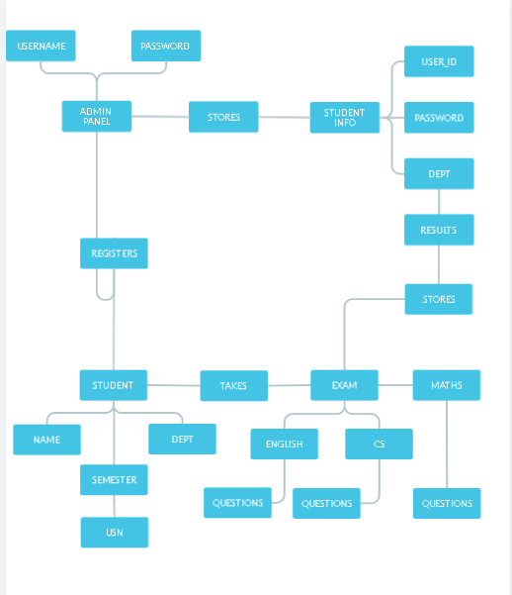

**4.SCHEMA OF THE ONLINE EXAMINTION SYSTEM**

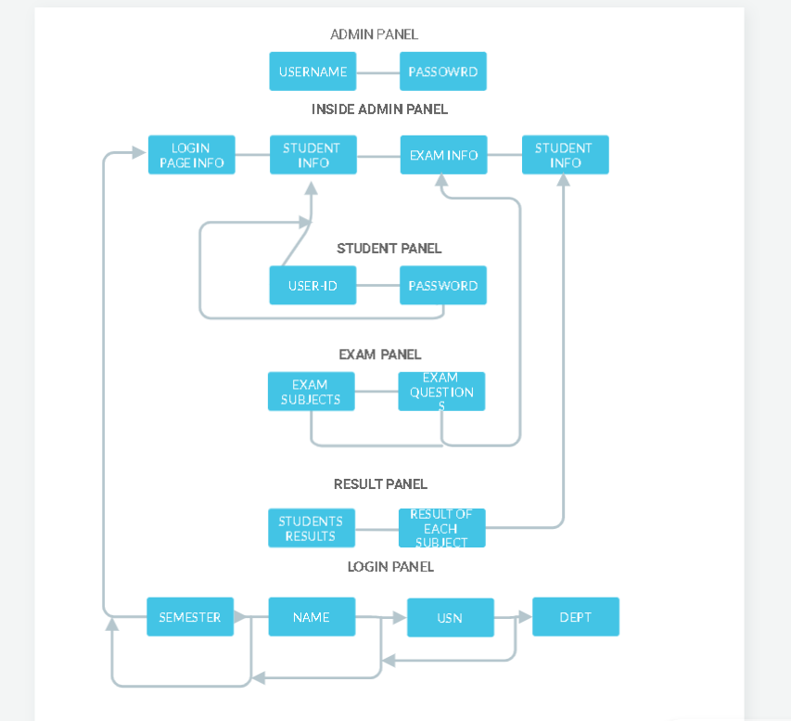

**USER INTERFACE DESIGN**

**Attach various screenshots of each page along with a brief discussion. Please give Figure numbers and names to each of the screenshot attached.**

**REFERENCES:**

**Please provide all the website links you used as reference to build the project**